**THE VIVONNE BAY**

**Vivonne Bay** ([French](https://en.wikipedia.org/wiki/French_language): ***Baie Vivonne***) is a [bay](https://en.wikipedia.org/wiki/Bay) in the Australian state of [South Australia](https://en.wikipedia.org/wiki/South_Australia) located on the south coast of [Kangaroo Island](https://en.wikipedia.org/wiki/Kangaroo_Island) about 61 kilometres (38 mi) from [Kingscote](https://en.wikipedia.org/wiki/Kingscote,_South_Australia" \o "Kingscote, South Australia), the island's main town, and which was named by the members of [Baudin expedition to Australia](https://en.wikipedia.org/wiki/Baudin_expedition_to_Australia" \o "Baudin expedition to Australia) who visited the bay in January 1803. In a survey of 10,000 beaches by Professor Andrew Short, director of [Sydney University's](https://en.wikipedia.org/wiki/Sydney_University) marine studies centre, the beach at Vivonne Bay was adjudged as one of the best in Australia.

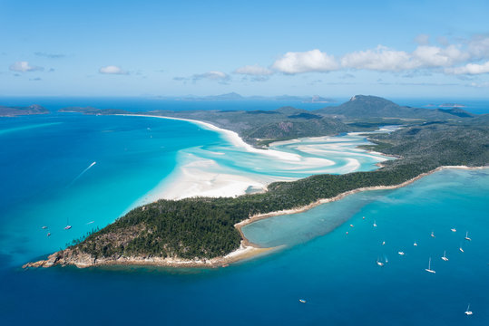

Vivonne Bay has been described in an American source as being "a bight in the coast" between Point Ellen in the west and the Eleanor River in the east which is referred to as being the ‘Mary River’ and which is located about 1.75 nautical miles (3.24 km; 2.01 mi) north-northeast of Point Ellen. While the American source does nominate an eastern extremity, the official Australian source does not.